Unit2 Cities Lesson4
Homework
- 完成表格并介绍自己喜爱的地点。
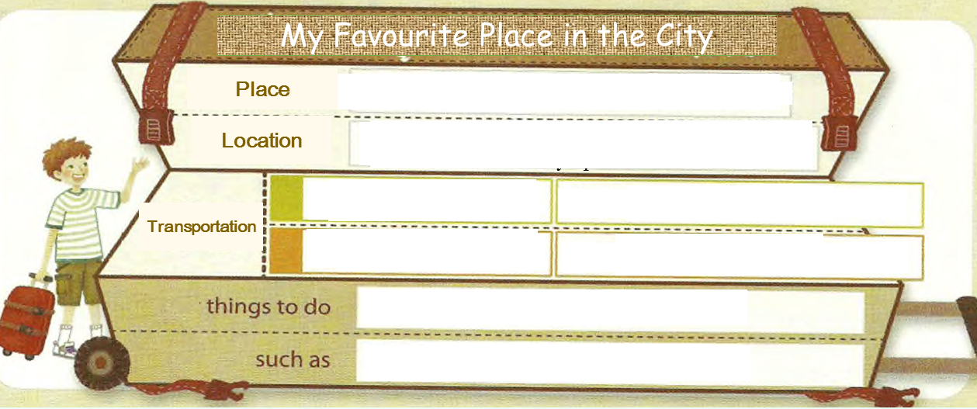
- 读故事完成练习
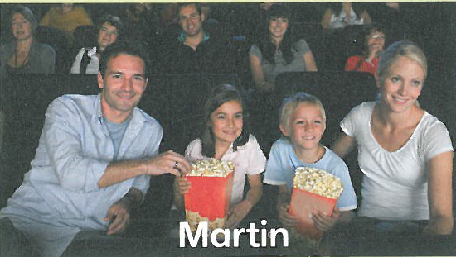
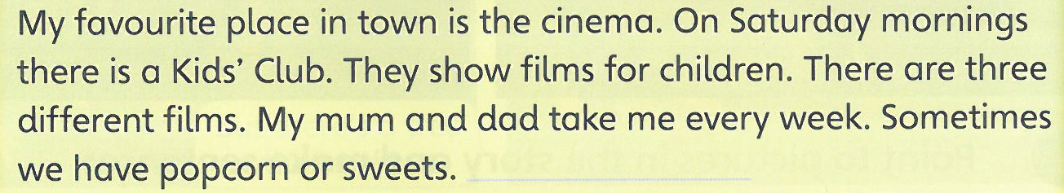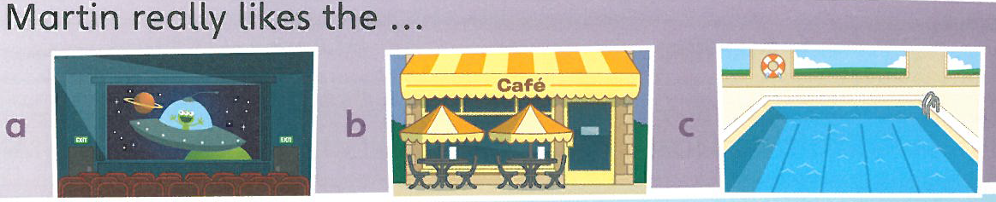
- How many films does the cinema show at Kids’ Club? ( Three.)
- What does Martine eat at the cinema? (Popcorn or sweets)

