My school（第三课时）课后作业
- 根据提示，为相应场所选择所做的事情。

- draw a pictures B. sing a song C. play football D. have lunch

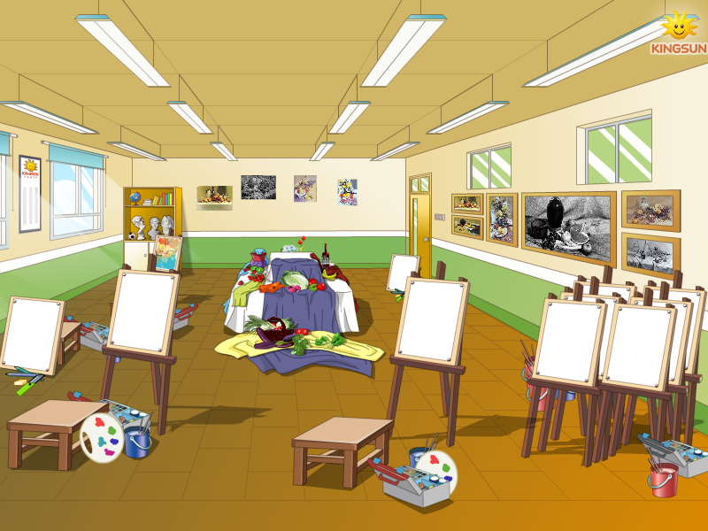

（ ） （ ） ( ) ( )

- 单项选择。
( ) a. ___________to our school.
- Welcome B. welcome C. Come
( ) b. -________ the music room?
-No, it isn’t.
A. Are they B. Is that C. Does it
( ) c. It’s time for lunch. Let’s go to the ___________.
- lunch room B. music room C. art room

3.. 根据图片，写出正确答案。

a. The music room is on the ____________floor.

b. The art room is on the __________ floor.

c. The gym is __________ the library.

{答案}
1. B C D A
2. A B A
3. first; second; next to

