**Unit 4 Free Time Lesson 3**

**Homework**

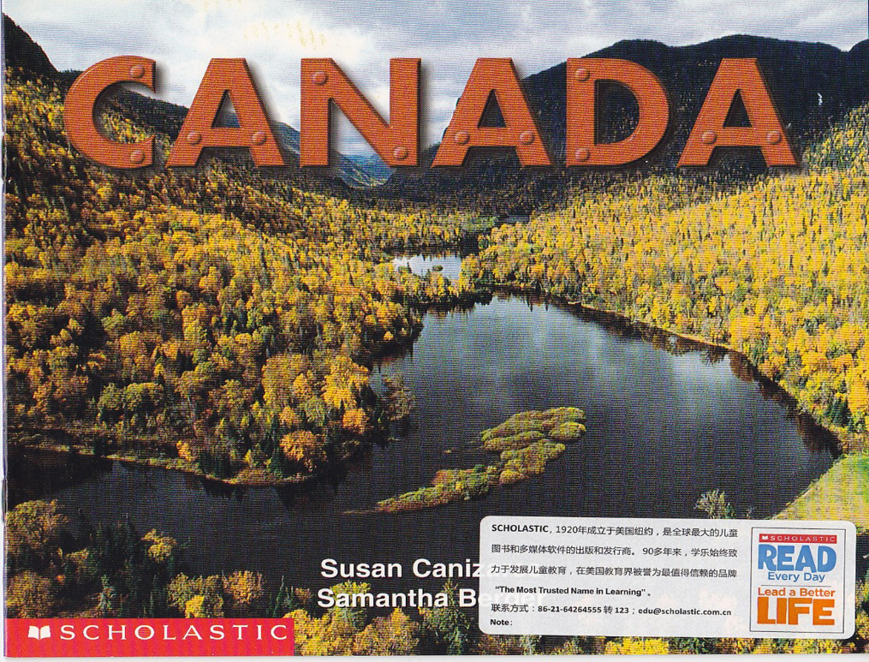

1. Read the passage again.

2. Write one of your wonderful weekends.

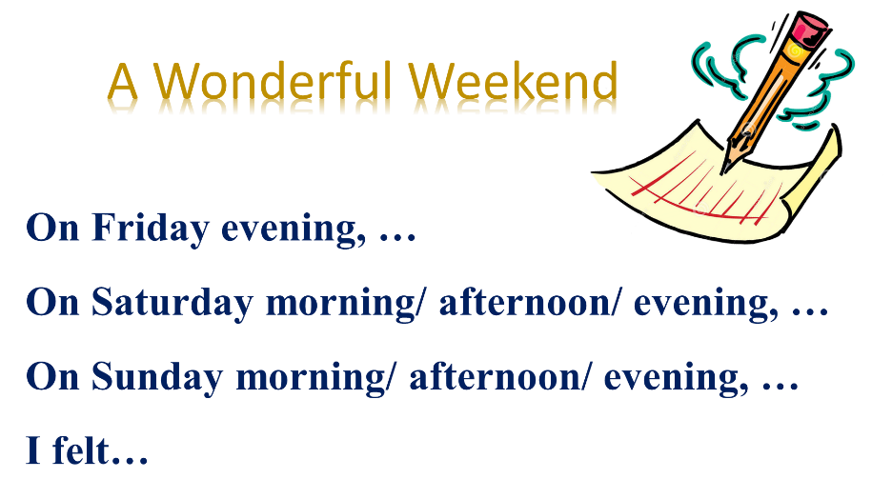

可扫描右图二维码下载课本录音。