**Unit 1 Visiting Canada Lesson 4作业**

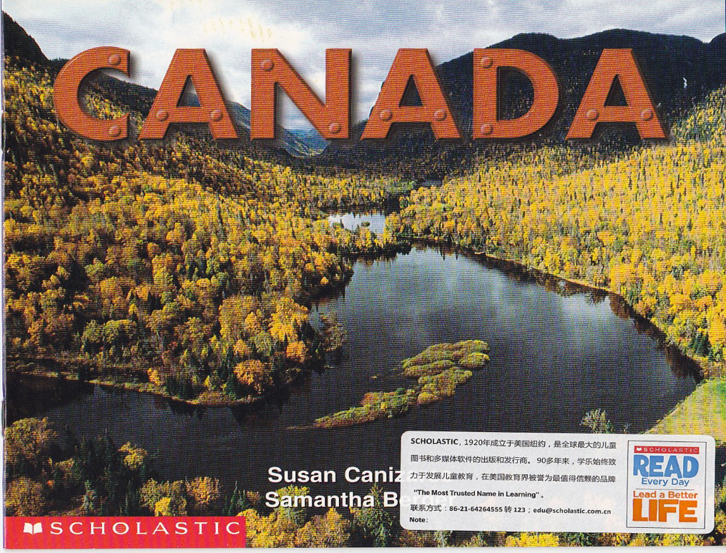

1. Read the story again.

2. Retell the story with the organizer.

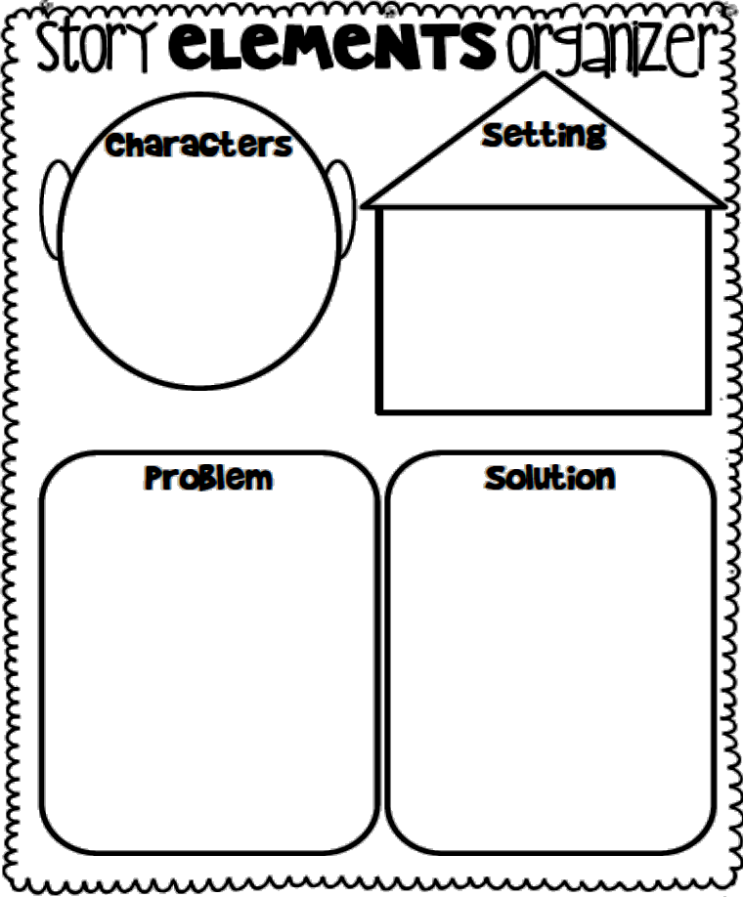



扫描右图二维码下载故事录音