**Unit 1 Visiting Canada Lesson 3作业**

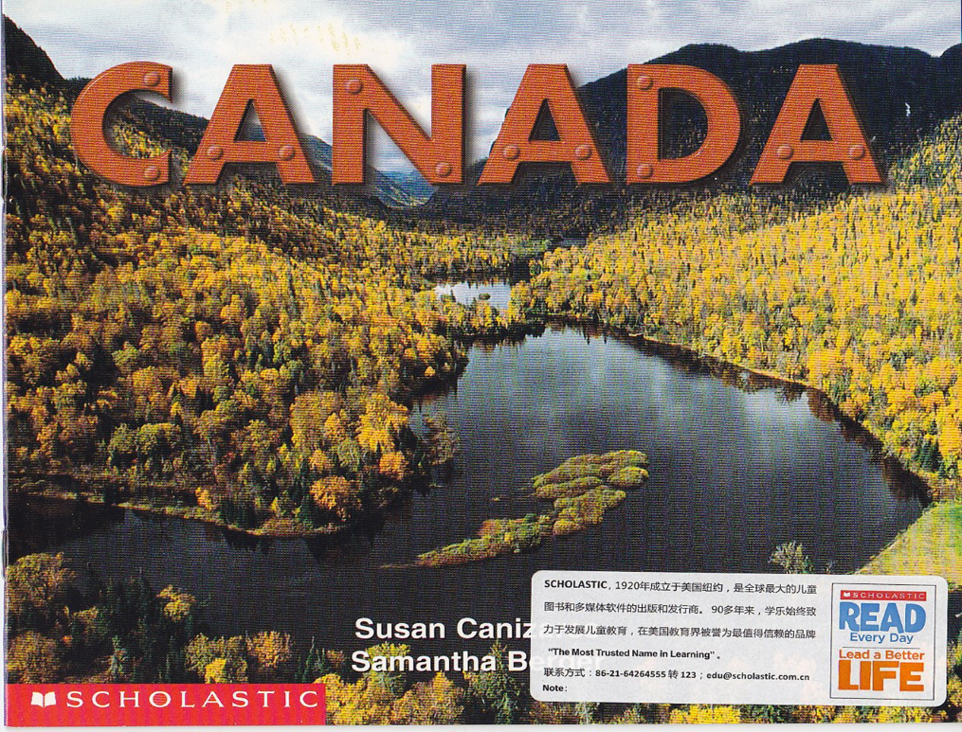

1. Listen and read the letter at least three times.

2. Finish Part D

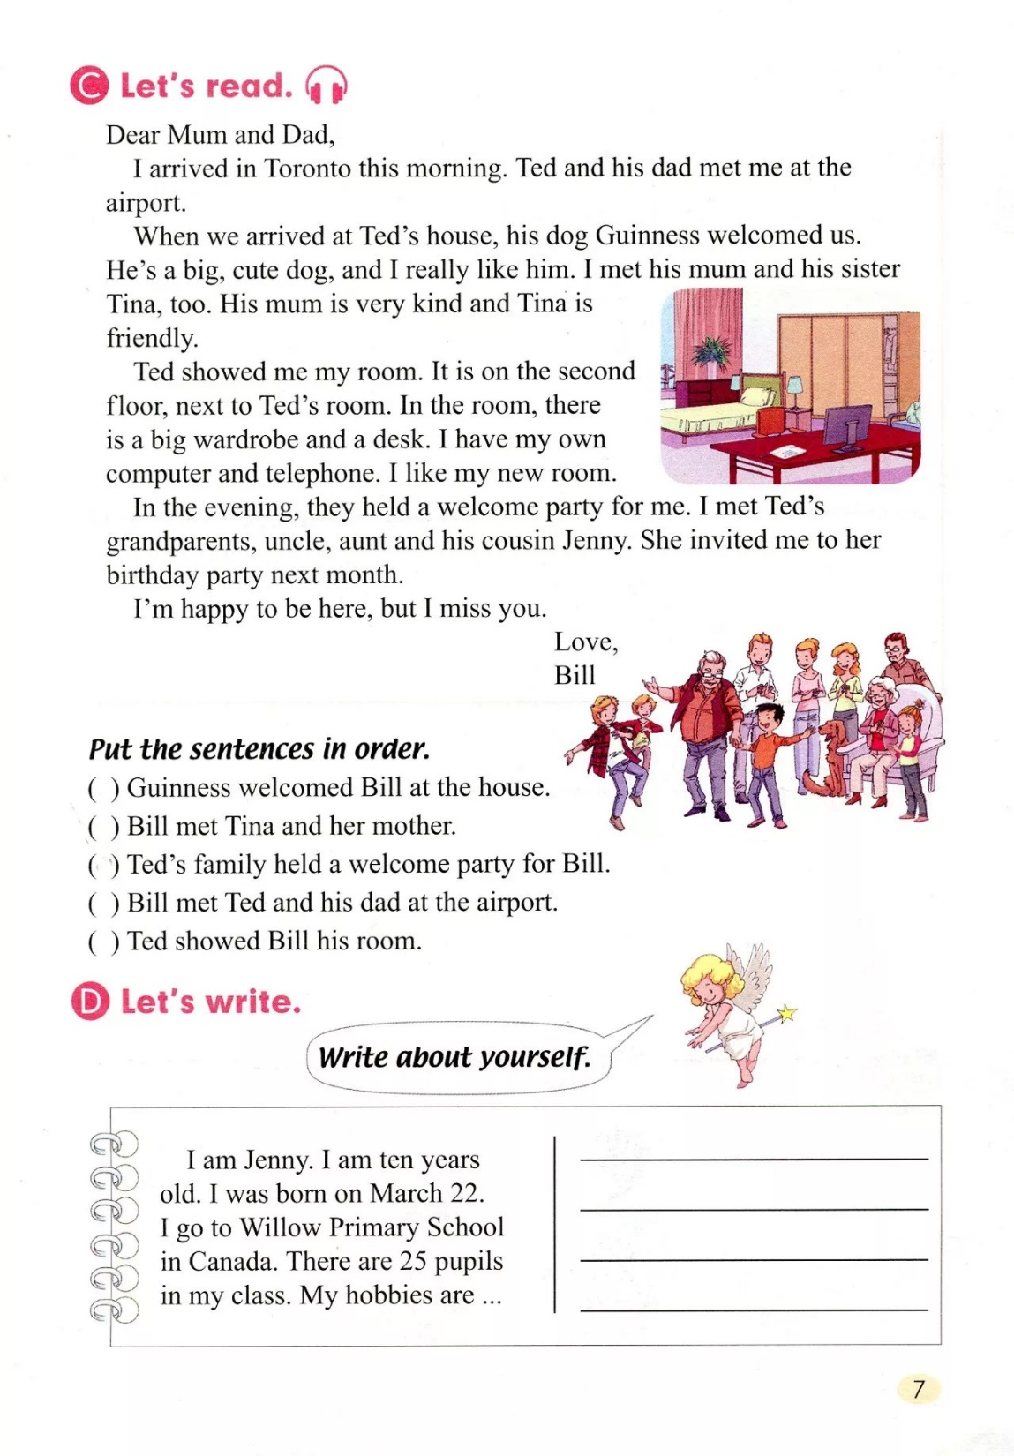



可扫描右图二维码课本录音内容。