Unit 2 Last Weekend Part B课后作业
- 请你阅读文章，完成邮件内容。
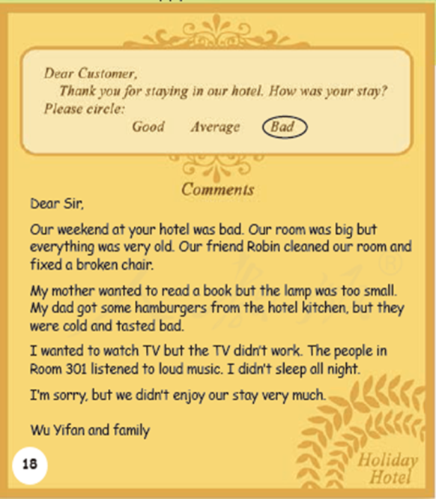
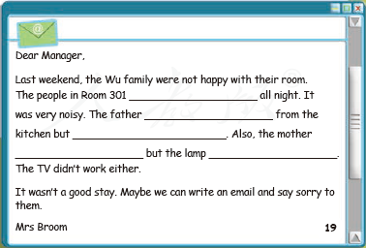

2．请你使用括号内所给动词的适当形式填空：
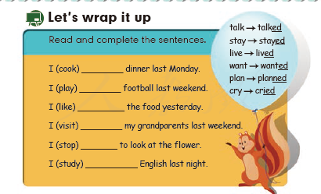

【答案】
- listened to loud music; got some hamburgers; they were cold and tasted bad; wanted to read a book; was too small.
- cooked; played; liked; visited; stopped; studied

